# Module R Programming

Authors: David Jacobson, Ph.D., and Wei Wei, Ph.D.

Competency Area: General Programming

**Learning objectives**: After this module, students will be able to

* Download and Install R and RStudio
* Import and export data, and create a data frame
* Install and load R packages
* Perform vector operations
* Inspect and edit/manipulate data frames
* Merge two data frames
* Use logical operators
* Manage missing data
* Create R functions
* Use loop and if-else statements
* Generate descriptive statistics and use basic R functions
* Debug
* Define numeric, character, date, and logical data types
* Create matrices
* Perform basic matrix arithmetic operations

**Resources**

<https://CRAN.R-project.org>

<https://cran.cnr.berkeley.edu/>

[www.rstudio.com/products/RStudio/](http://www.rstudio.com/products/RStudio/)

<https://www.rstudio.com/products/rstudio/download/>

<http://www.cyclismo.org/tutorial/R/basicOps.html>

http://www.r-tutor.com/r-introduction/vector/vector-arithmetics

<https://cran.cnr.berkeley.edu/doc/manuals/r-release/R-intro.pdf>

<http://www.biostatisticien.eu/springeR/dbsnp123.dat>

<https://dzone.com/articles/learn-r-how-extract-rows>

<https://www.crained.com/822/how-to-use-the-str-function-in-r/>

<http://www.endmemo.com/program/R/names.php>

<http://www.endmemo.com/program/R/summary.php>

<http://www.endmemo.com/program/R/ncol.php>

<http://www.endmemo.com/program/R/dim.php>

<http://www.endmemo.com/program/R/length.php>

<http://www.r-tutor.com/r-introduction/data-frame/data-frame-column-vector>

<http://www.r-tutor.com/r-introduction/data-frame/data-frame-column-slice>

<http://www.datasciencemadesimple.com/cbind-in-r/>

<https://www.r-bloggers.com/which-function-in-r/>

<https://howtoprogram.xyz/2018/01/10/r-remove-delete-column-data-frame/>

https://www.r-exercises.com/2016/01/04/data-frame-exercises/

<https://www.r-bloggers.com/5-ways-to-subset-a-data-frame-in-r/>

<http://rprogramming.net/subset-data-in-r/>

<http://www.endmemo.com/program/R/order.php>

<http://www.endmemo.com/program/R/rbind.php>

<https://www.statmethods.net/management/merging.html>

<http://www.datasciencemadesimple.com/join-in-r-merge-in-r/>

<http://www.datasciencemadesimple.com/stack-and-unstack-function-in-r/>

<http://www.endmemo.com/program/R/transform.php>

<https://www.datamentor.io/r-programming/operator>

<http://www.datasciencemadesimple.com/any-and-all-function-in-r/>

<https://www.statmethods.net/input/missingdata.html>

https://swcarpentry.github.io/r-novice-inflammation/02-func-R/

<http://rfunction.com/archives/770>

<https://stat.ethz.ch/R-manual/R-patched/library/base/html/numeric.html>

<http://www.r-tutor.com/r-introduction/basic-data-types/integer>

<http://www.r-tutor.com/r-introduction/basic-data-types/character>

<https://www.dummies.com/programming/r/how-to-convert-a-factor-in-r/>

<http://www.endmemo.com/program/R/nchar.php>

<https://www.stat.berkeley.edu/~s133/dates.html>

<https://www.rdocumentation.org/packages/base/versions/3.5.0/topics/logical>

<http://www.datasciencemadesimple.com/sample-function-in-r/>

<http://www.endmemo.com/program/R/mean.php>

<http://astrostatistics.psu.edu/su07/R/html/stats/html/weighted.mean.html>

<http://www.r-tutor.com/elementary-statistics/numerical-measures/variance>

<http://www.r-tutor.com/elementary-statistics/numerical-measures/standard-deviation>

<http://www.endmemo.com/program/R/max.php>

<http://www.r-tutor.com/elementary-statistics/numerical-measures/median>

<http://www.endmemo.com/program/R/summary.php>

<http://www.r-tutor.com/elementary-statistics/numerical-measures/quartile>

<http://www.r-tutor.com/r-introduction/matrix/matrix-construction>

<http://www.r-tutor.com/r-introduction/matrix>

<https://stat.ethz.ch/R-manual/R-devel/library/base/html/matrix.html>

<https://www.dummies.com/programming/r/how-to-do-matrix-arithmetic-in-r/>

<http://www.endmemo.com/program/R/det.php>

<http://www.endmemo.com/program/R/diag.php>

<http://www.johnmyleswhite.com/notebook/2009/12/16/quick-review-of-matrix-algebra-in-r/>

<http://philender.com/courses/multivariate/notes/matr.html>

<http://www.datasciencemadesimple.com/rowsums-colsums-rowmeans-columnmeans-r/>

<https://www.r-bloggers.com/r-tutorial-on-the-apply-family-of-functions/>

https://www.dummies.com/programming/r/r-for-dummies-cheat-sheet/

**Contents**

### Download and Install R

R is a free software for statistical computing and graphics. It compiles and runs on a wide variety of UNIX platforms, Windows and Mac OS. Among other things, R has

* An effective data handling and storage facility
* A suite of operators for calculations on arrays, in particular matrices
* A large, coherent, integrated collection of intermediate tools for data analysis
* Graphical facilities for data analysis
* A well developed, simple and effective programming language which includes conditionals, loops, user defined recursive functions and input and output facilities. (Venables et al. 2018)

There are basic R functions to apply statistical analysis and graphing. Besides the basic functions, there are different packages supplied with R. The R packages can be downloaded from the CRAN sites via <https://CRAN.R-project.org>.

To download R, please go to the following link <https://cran.cnr.berkeley.edu/>. There are three options to download R: R for Linux, R for (Mac) OS X, and R for Windows. You can choose one of the options based on the type of computer you have.

If you choose the “Download R for Windows” option, the link takes you to a site where there is a link showing “install R for the first time”. Click on that link, and it takes you to another site where there is a link “Download R [version] for [operation system]”. Click on that link, save the executive file and run the .exe file after downloading.

If you choose the “Download R for (Mac) OS X” option, the link takes you to a site where there is a link showing “R-[version].pkg” under “Latest release”. Click on that link, save the file and run the file after downloading.

### Download and Install RStudio

RStudio is an integrated development environment (IDE) for R. It includes a console, syntax-highlighting editor that supports direct code execution, as well as tools for plotting, history, debugging and workspace management (based on [www.rstudio.com/products/RStudio/](http://www.rstudio.com/products/RStudio/)).

To install RStudio, you will have to install R first. RStudio is also an open resource software that runs on Windows, Mac, and Linux, or in a browser connected to RStudio Server or RStudio Server Pro (Debian/Ubuntu, RedHat/CentOS, and SUSE Linux).

To download RStudio, go to <https://www.rstudio.com/products/rstudio/download/>. Use any link in the “Installers for Supported Platforms” section to download and install RStudio.

### Introduction to R and RStudio

Once RStudio is installed, you can find it from the Start Menu of your computer. The starting page of RStudio is as following (figure 1):

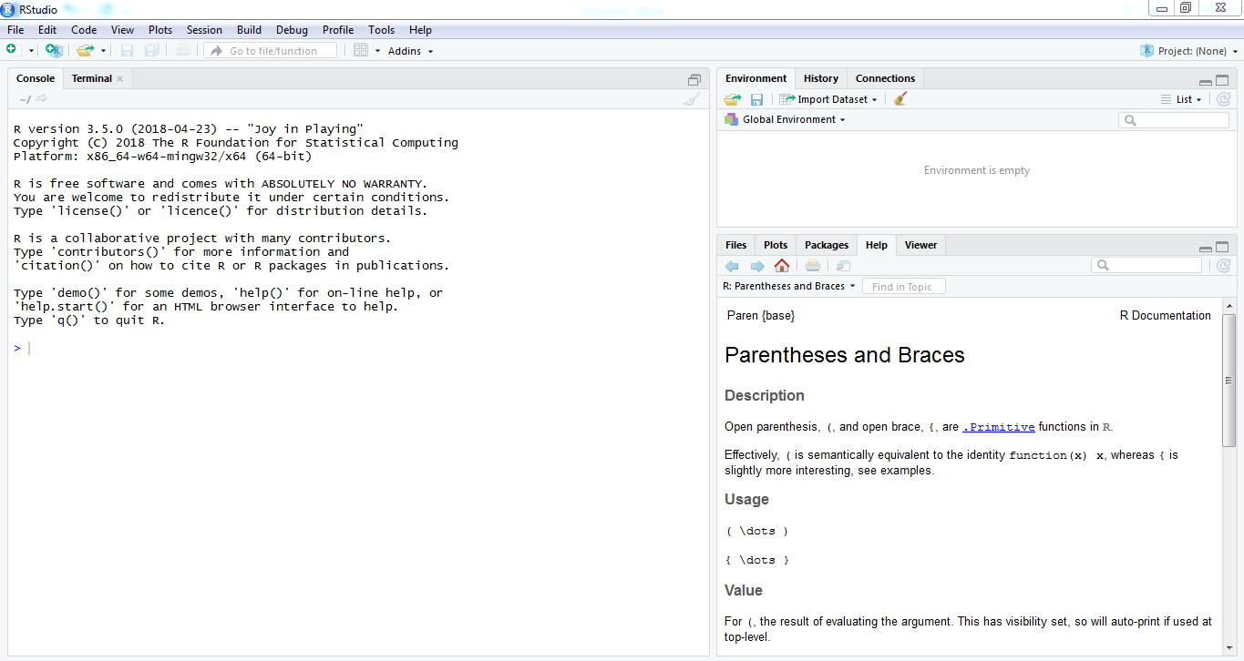

Figure 1. Starting page of RStudio

RStudio starts with three windows: console window, environment/history/connections, and files/plots/packages/help/viewer window. The console window is where you type the code or R commands. The console window starts with the introduction of R and its version. To clear the console window, use Ctrl+L.

The environment window stores any object, value, function or anything you create during your R session. The history window keeps a record of all previous commands. It helps when testing and running processes. Here you can either save the whole list or you can select the commands you want and send them to the console or an R script to keep track of your work (Torres-Reyna 2013). For example, if highlight the previous command of y=c(2,4,6) and click on “To Console”, the command of y=c(2,4,6) is moved to the console window (figure 2).

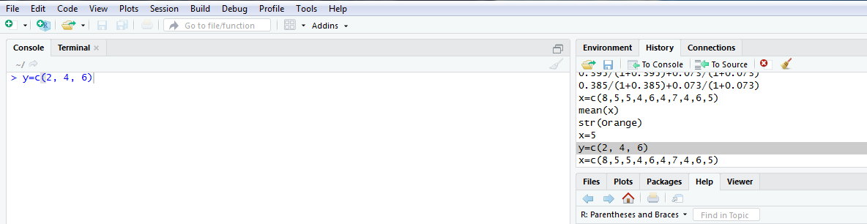

Figure 2. Interaction between History window and Console window.

The Files window shows all of the files under the current working directory. The plots window shows a graph that you create from the current command. To review previous graphs, use the blue arrow on top of the graph (figure 3).

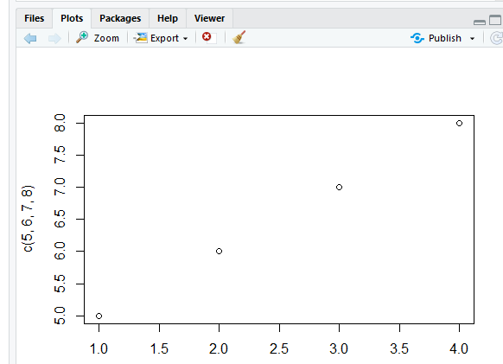

Figure 3. Plot window in RStudio

The package window shows the list of add-ons included in the installation of RStudio. If checked, the package is loaded into R, if not, any command related to that package won’t work

(Torres-Reyna, 2013). You can install other packages by clicking on the “Install Packages” icon and type the package name in the blank (figure 4).

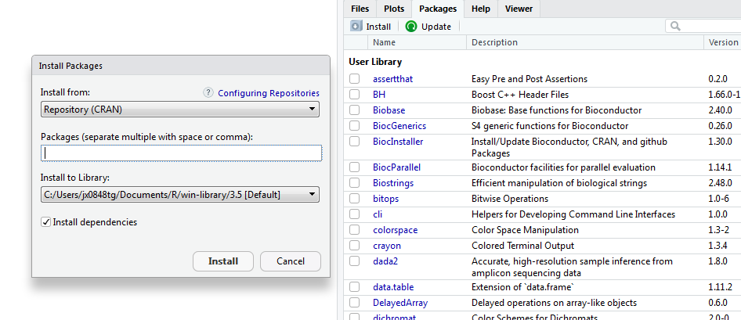

Figure 4. Install an R package from the Packages window.

The help window shows R documentation of the function or command. If you need help on looking up any command, type the command in the search window (figure 5).

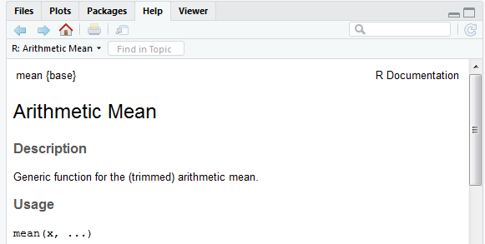

Figure 5. Search in Help window.

RStudio has another window, which is the R script window. To get to the R script window, click “File” -> “New file” ->“R Script” (figure 6). R script is where you keep a record of your code.

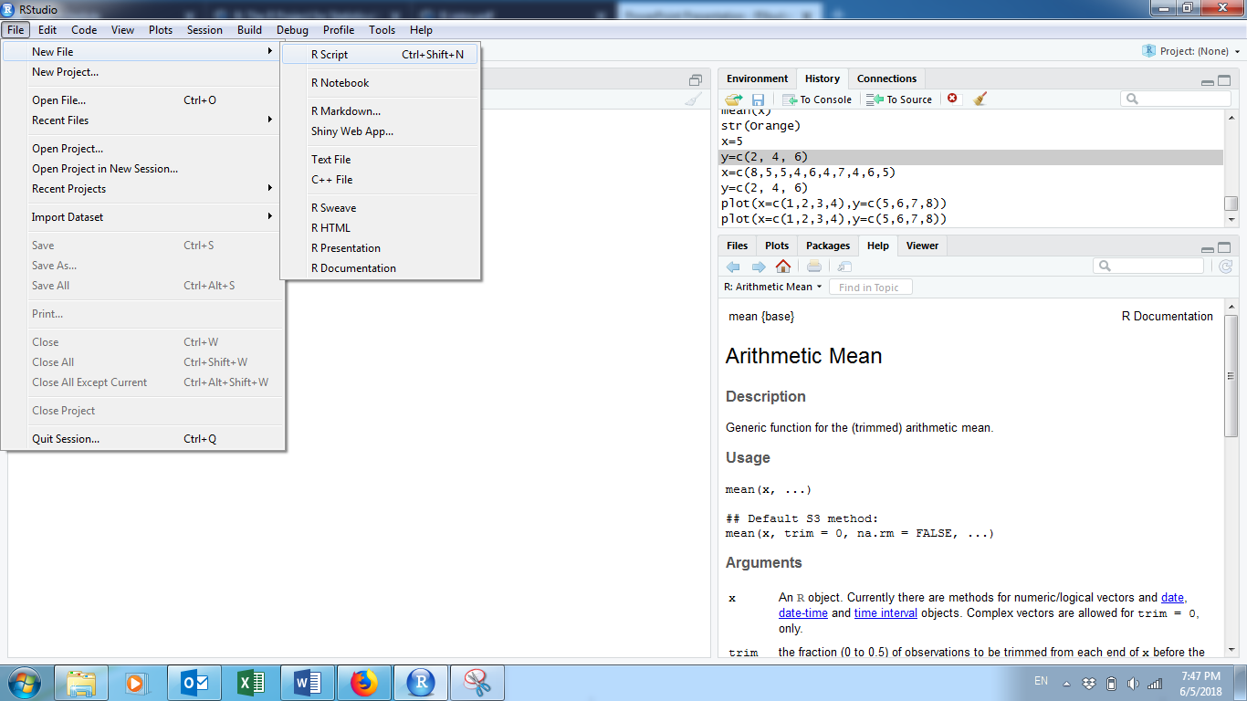

Figure 6. Create a new R script.

When typing the commands in the console window, it issues a prompt when it expects input commands. The default prompt is “>”, which on UNIX might be the same as the shell prompt, and so it may appear that nothing is happening. For example, if typing “x=5”, and enter, you will not see what x value is unless if you type “x” in the following line (figure 7).

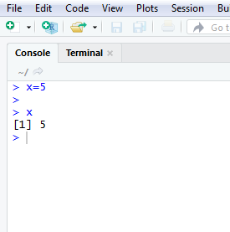

Figure 7. Example of writing R command.

To assign a vector to a variable, use “variable=c(… , … , …)”. For example, y=c(1,2,3). The “c” is to initiate a vector (figure 8). The elements in the vector need to be separated by comma. To assign a value to a variable or vector, we can use either “=” or “<-“ (figure 8).

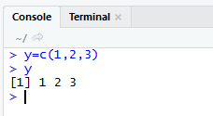 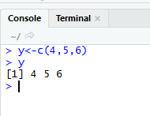

Figure 8. Create an R vector.

R is case sensitive, so A and a are different symbols and would refer to different variables. The set of symbols which can be used in R names depends on the operating system. Normally all alphabets and numbers are allowed, plus “.” and “_”, with the restriction that a name must start with a letter or “.”.

R commands are separated by a new line. Comments can be inserted anywhere with a hashmark “#”. Everything from # to the end of the line is a comment. If a command is not complete at the end of a line, R will give a different prompt, by default “+” on second and subsequent lines and continue to read input until the command is syntactically complete.

### Vector Operations

Now that we know how to create a vector, we might want to multiply each element by a scalar constant. In R, this is a simple operation using just the multiplication operator (*).

*Example 1:* Multiply each element of the vector (1, 2, 3) by 4 (figure 9).

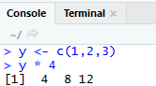

Figure 9. Vector Operation Example: Multiplication.

Addition, subtraction and division are just as easy. (<http://www.cyclismo.org/tutorial/R/basicOps.html>)

*Example 2:* For the vector in example 1, add 3 to each element, subtract 2 from each element and divide each element by 5 (figure 10).

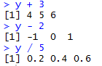

Figure 10. Vector Operation Examples: Addition, Subtraction and Division.

Vector operations can be extended even further. Let’s say we have two vectors of equal length. Each of the corresponding elements can be operated on together. ([http://www.r-tutor.com/r-introduction/vector/vector-arithmetics](http://www.r-tutor.com/r-introduction/vector/vector-arithmetics%20))

*Example 3:* Create two vectors: x = (10, 20, 30) and y = (40, 50, 60). Do the following operations: x+y, x-y, x*y, and x/y (figure 11).

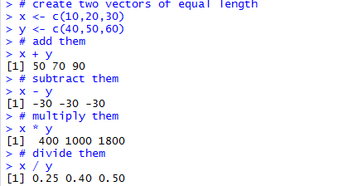

Figure 11. Examples of Vector Operations on Two Vectors

*Activity 1:*

Create two vectors: x=(3,5,7), and y=(12, 2, 8), and do the following operation: x+y, 2*x, and y/3.

### Create a Data Frame in RStudio

A dataset in R is presented as a data frame. A data frame is a table with columns representing variables and rows representing individual cases. Following are the characteristics of a data frame:

* Column names should be non-empty
* Data stored in a data frame can be of numeric, factor or character type
* Each column should contain same number of data items

*Example 4*: Create a data frame showing the table below:

|  |  |  |  |
| --- | --- | --- | --- |
| Employment ID | Employer Name | salary | Start Date |
| A | Jack | 10.2 | 2012-1-2 |
| B | Mike | 32.7 | 2011-3-4 |
| C | Frank | 45.6 | 2010-9-7 |
| D | Kate | 57.9 | 2010-3-5 |
| E | Tom | 35.4 | 2009-8-7 |

Table 1. Example for a data frame

R code (figure 12):

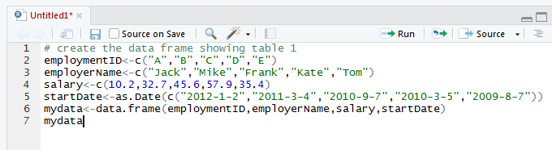

Figure 12. Example of creating a data frame.

Highlight the code and click on Run

This example is to create a data frame table with four columns and five rows plus a header row.

*Activity 2:*

The table below (table 2) recorded the information for five patients when they were admitted in the hospital. Create a data frame to show the information in table 2.

|  |  |  |  |  |
| --- | --- | --- | --- | --- |
| Patient ID | Gender | Temperature | Systolic Blood Pressure | Oxygen Level (%) |
| 1 | Female | 100.6 | 120 | 98 |
| 2 | Male | 99.8 | 130 | 96 |
| 3 | Female | 98.7 | 110 | 90 |
| 4 | Male | 98.2 | 109 | 97 |
| 5 | Male | 98.5 | 96 | 95 |

Table 2: activity to create a data frame

### Import Data to RStudio

There are two ways to import an Excel data file: 1) save the Excel file as .csv vile and use the command

filename<-read.csv(“directory.csv”, header=TRUE)

For example: mydata<-read.csv(“C:/Documents/data.csv”, header=TRUE)

The option of “header=TRUE” is to keep the header.

If your data is in .txt format, you can use the following command to read the data file into R

filename<-read.table(“directory.txt”,header=TRUE)

2) from the environment window, click “Import Dataset”->”From Text (base)”, and choose the data file, keep all default settings, and click “Import” (figure 13).

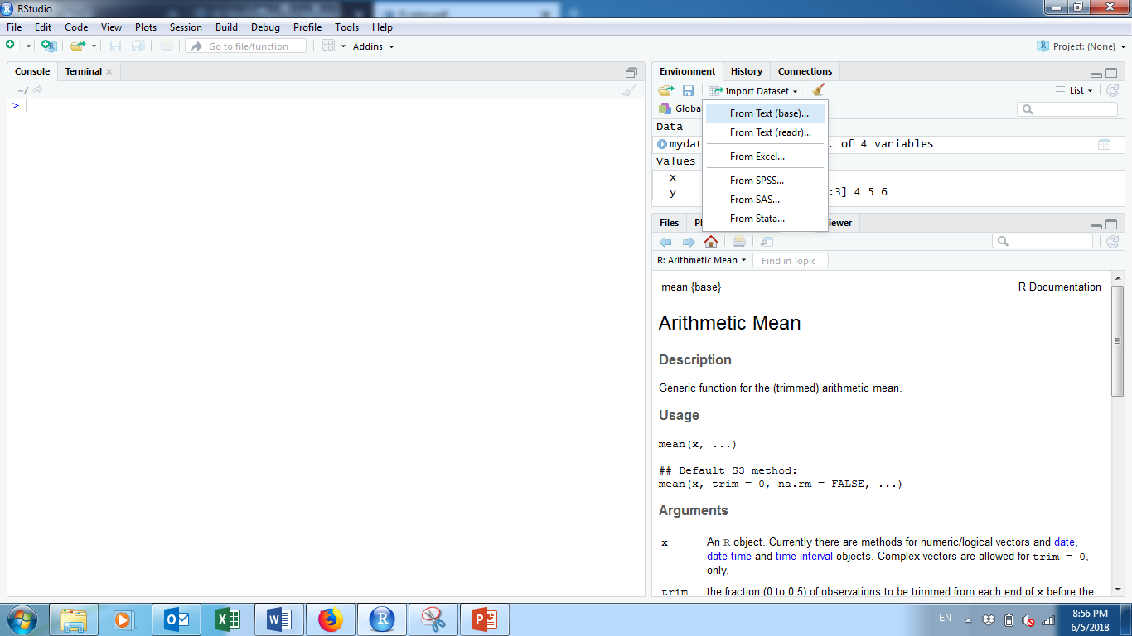

### 

Figure 13. Import a CSV file to R

If you need to import data from other software, such as SPSS, SAS, or Minitab, the following table gives the packages and R commands you can use.

|  |  |  |  |
| --- | --- | --- | --- |
| Software | Package | R function | File extension |
| SPSS | foreign | read.spss() | .sav |
| Minitab | foreign | read.mtp() | .mtp |
| STATA | foreign | read.dta() | .dta |
| SAS | foreign | read.xport() | .xpt |

Table 3. Packages and R importation commands

For large data files, you need to specify explicitly the type of each column. If you do not, R will have to read the entire file to check that numeric columns are indeed numeric. The following example illustrates this point with genomic data, well known for their large size. You will need to download the 50MB file from <http://www.biostatisticien.eu/springeR/dbsnp123.dat> to your computer, then try the instructions below (Lafaye de Micheaux et al. 2013).

*Example 5*: Read the genomic data from the website above.

tm<-Sys.time() #Gets the current time

dbsnp<-read.table(“file directory/dbsnp123.dat”)

Sys.time()<-tm

tm<-Sys.time()

dbsnp<-read.table(“file director/dbsnp123.dat”, colClasses=rep(“character”,3)

Sys.time()

### Export Data

To export R data into a .csv file, use the function “write.csv()”. To export R data into a .txt file, use the function “write.table()”. The command is

myfile<-write.csv(data, file=”directory”)

*Example 6:*

Based on the data frame created from example 4, export the data into a csv file (figure 14).

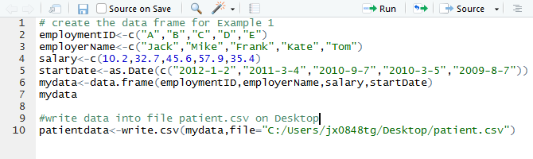

Figure 14. Example of export data into a CSV file.

*Activity 3:*

Export the data frame created from activity 2 as a csv file to the desktop of your computer.

### Inspecting Your Data

Now that we know how to create a data frame or import data, we will want to spot check it to make sure it looks right. We also want to understand the structure of the table in order to know how to work with it. Seeing short excerpts of your data is one easy way to inspect your data. You can do this using the standard bracket notation for data frames: df[rows, columns] where df is the name of the data frame, and rows and columns are references to the rows and columns of interest. ([https://dzone.com/articles/learn-r-how-extract-rows](https://dzone.com/articles/learn-r-how-extract-rows%20) )

*Example 7:* Using the mydata data frame created in example 1, reference the first three rows and first three columns. Figure 15 shows the most rudimentary way to reference rows and columns of a data frame.

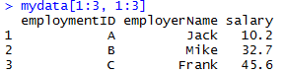

Figure 15. First three rows and first three columns of the mydata data frame from Example 1.

Here we are showing the first three rows and first three columns of the mydata data frame. You do this by passing two vectors, 1:3 and 1:3. That is shorthand for c(1,2,3) and c(1,2,3). Since the notation for picking rows and columns is based on vectors, you can deduce that any arbitrary set of rows and columns can be selected. Consider the example shown in figure 16.

*Example 8:* Using the mydata data frame, select rows 5, 1, and 3 and columns 3, 2, and 1. Do the selection in the noted order (figure 16).

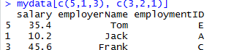

Figure 16. Arbitrary subset of mydata.

Notice the order of the vector values determines the order of the rows and columns. That is, row number 5 prints first, followed by 1 and 3. Vector order matters.

If we want to get all rows or all columns from the data frame, we can leave that part blank.

*Example 9:* For the mydata data frame, print the first three rows and all columns. Then print all the rows and the first three columns (figure 17).

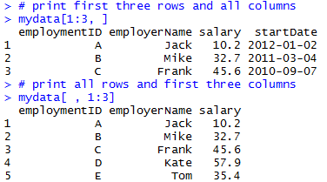

Figure 17. Printing all rows or all columns.

*Activity 4:* Consider the built-in data frame **Formaldehyde.**

1. Extract the elements of the third row of this data frame.
2. Extract the elements of the **carb** (carbohydrate) column.

#### Data Structure – str Function

The str( ) function gives us a succinct outline of what the data frame contains. ([https://www.crained.com/822/how-to-use-the-str-function-in-r/](https://www.crained.com/822/how-to-use-the-str-function-in-r/%20) )

*Example 10:* Use the str( ) function on the mydata data frame (figure 18).

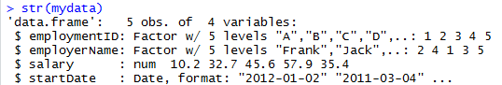

Figure 18. Structure (str) of the mydata date frame.

The first row provides some quick stats: 5 observations (rows) and 4 variables (columns). Below that, we get three columns of information: column name, data type and a sampling of the first few values. Be sure to pay attention to the second column. Make sure columns that are supposed to be numbers are numeric (num) or integer (int), character columns are chr or factor, date columns are date, etc. Why? R will not let us do math on character variables or run date functions on non-date columns.

#### Column names – names Function

If you just want a listing of column names, you can run the names( ) function. (<http://www.endmemo.com/program/R/names.php>)

*Example 11:* Generate the vector of column names for the mydata data frame (figure 19).



Figure 19. Vector of column names of the mydata data frame.

Wondering what that number is in front of the vector every time we print it? This represents the index number of the first item in that line. For example, employmentID is item number one, startDate is item number four.

You can access specific values of a vector with the vector[index number] notation.

*Example 12:* Extract the first three column names for the mydata data frame from the names( ) vector (figure 20).



Figure 20. Extracting certain column names.

The above example shows a basic vector operation to get the first three values in the names( ) vector.

#### Summary Stats – summary Function

summary( ) is often useful if your data frame has several numeric variables or factors. ([http://www.endmemo.com/program/R/summary.php](http://www.endmemo.com/program/R/summary.php%20) )

*Example 13:* Use the summary( ) function on the mydata data frame (figure 21).

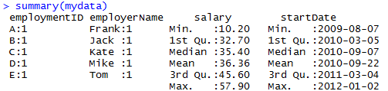

Figure 21. summary( ) of the mydata data frame.

For each numeric variable, we get summary statistics like min, max, mean, etc.

You can also use the bracket notation if you are interested in summary( ) for only specific columns.

*Example 14:* Print the summaries on only salary and startDate (figure 22).

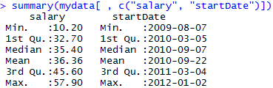

Figure 22. summary( ) of selected columns.

By leaving the rows reference blank, we are keeping all rows.

#### Other Quick Inspection Functions

Here are a few more functions that are useful but limited in scope:

* nrow( ) provides the number of rows in a data frame (<http://www.endmemo.com/program/R/ncol.php>)
* ncol( ) provides the number of columns in a data frame ([http://www.endmemo.com/program/R/ncol.php](http://www.endmemo.com/program/R/ncol.php%20))
* dim( ) provides the number of rows and columns in a data frame. The output is a vector of those two numbers. ([http://www.endmemo.com/program/R/dim.php](http://www.endmemo.com/program/R/dim.php%20))
* length( ) counts the number of items in a vector. ([http://www.endmemo.com/program/R/length.php](http://www.endmemo.com/program/R/length.php%20))

*Example 15:* Use the functions nrow( ), ncol( ), and dim( ) to find the number of rows and columns in the mydata data frame. Also find the length of the salary variable (figure 23).

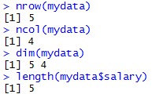

Figure 23. Examples of the use of other data frame inspection functions.

*Activity 5:* Consider the built-in **USArrests** data frame.

1. Determine the number of rows and columns for this data frame.
2. Calculate the median of each column of this data frame.

### Working with Columns

Now that you’ve created a data frame or imported data and done some light inspection to see what the data looks like, let’s start doing stuff to your data. Let’s start with columns.

There are four basic things we will want to do with columns in R:

1. Refer to columns
2. Create columns
3. Rename columns
4. Remove columns

#### Referencing Columns – Referencing a Single Column

To reference a single column in R, we use df$columnname where df is the name of the data frame and columnname is the name of the column. The most important thing to know is that this is a vector. ([http://www.r-tutor.com/r-introduction/data-frame/data-frame-column-vector](http://www.r-tutor.com/r-introduction/data-frame/data-frame-column-vector%20))

*Example 16:* Use the mean( ) and sd( ) functions to find the mean and standard deviation of the salary variable. Also extract the specific values from the employerName variable (figure 24).

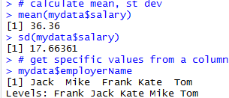

Figure 24. Referencing single columns of the mydata data frame.

We ran statistical functions on the salary column. Then we pulled the values of the employerName column.

#### Referencing Columns – Referencing Multiple Columns

Sometimes we want to reference multiple columns in a function, or extract a few columns and ignore the rest.

*Example 17:* Use the bracket notation to find the summaries of the employerName and salary variables of the mydata data frame (figure 25). (<http://www.r-tutor.com/r-introduction/data-frame/data-frame-column-slice>)

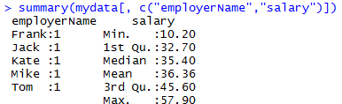

Figure 25. Referencing multiple columns of the mydata data frame.

In the df[[rows, columns] notation, by leaving the rows reference blank, we are requesting all rows be considered.

All we’re doing here is using a vector of column names to specify the columns we wish to keep, and plugging them into the summary( ) function. The minimum salary is 10.20, the maximum is 57.90 and the average salary is 36.36.

#### Creating Columns

Let’s create two new columns for the mydata date frame:

* Age
* State of Residency

*Example 18:* Create the following vectors: age = (25,32,30,45, 39) and ResidencyState = (“MN”, “WI”, “MN”, “MN”, “WI”). Create a new data frame by adding age and ResidencyState as columns utilizing the cbind( ) function (figure 26). ([http://www.datasciencemadesimple.com/cbind-in-r/](http://www.datasciencemadesimple.com/cbind-in-r/%20))

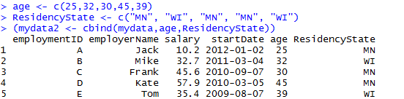

Figure 26. Addition of two new columns to the mydata data frame.

#### Renaming Columns

There are usually many ways to accomplish the same thing in R. Renaming columns in a data frame is one example. The names( ) function provides a vector of column names. We can change the names of the columns by changing the values of that vector directly.

*Example 19:* Let’s start by making a copy of the mydata2 data frame (figure 27).

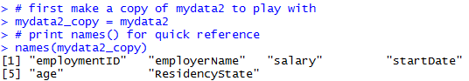

Figure 27. Renaming columns of mydata2 – setup.

We have created a copy of the mydata2 data frame and printed the names of the columns, just for reference.

*Example* 20: Now let’s rename columns: Rename the employmentID column to ID, the employerName column to Name, and the ResidencyState column to State (figure 28).

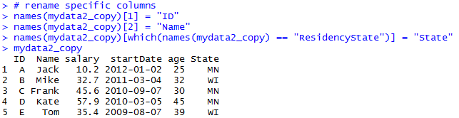

Figure 28. Renaming columns

Since names( ) is simply a vector, we can work with names( ) as we would any other vector.

In the first two lines of code in figure 28, we renamed columns 1 and 2 by assigning those vector elements the new column names. The third line uses the which( ) function to replace the hard-coded index numbers. ([https://www.r-bloggers.com/which-function-in-r/](https://www.r-bloggers.com/which-function-in-r/%20))

*Example 21:* Use the which( ) function to return the index number corresponding to ResidencyState in the mydata2 data frame (figure 29).



Figure 29. Using which( ) function.

As you can see, which( ) returns the index number corresponding to the vector value in question. Reading that code almost translates to English: “which item in names(mydata2) is equal to ‘ResidencyState’?”

#### Removing Columns – The Simple Way

Sometimes we want to delete columns to simplify our data frame. There are a few ways to remove a column. We will show you two: a simple way and a less simple (but more flexible and programmable) way. ([https://howtoprogram.xyz/2018/01/10/r-remove-delete-column-data-frame/](https://howtoprogram.xyz/2018/01/10/r-remove-delete-column-data-frame/%20))

*Example 22:* Remove the column age from mydata2 because we do not plan on using it. Figure 30 illustrates how you do it.

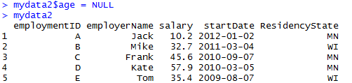

Figure 30. Deleting the age column from the mydata2 data frame.

By setting the column to NULL (case-sensitive), we remove the column from the data frame.

#### Removing Columns – The Less Simple, but more Flexible and Programmable Way

You saw the which( ) function above in the *Rename Columns* section. We can also use this function to remove columns by providing negative index numbers related to the columns we want to remove.

*Example 23:* Make a copy of the mydata2 data frame from example 22 with age removed. Then delete the following columns using negative index numbers: employmentID, startDate, and ResidencyState (figure 31).

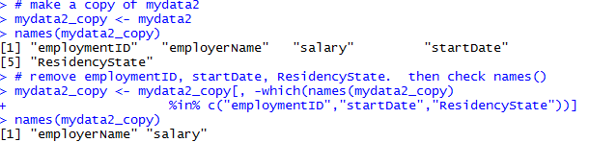

Figure 31. Deleting multiple columns programmatically.

The which( ) function returns the list of vector index numbers associated with the three specified columns. The negative sign in front of which( ) negates that vector of index numbers.

*Example 24:* Using the which( ) function, identify the column index numbers for the columns removed in example 23 (figure 32).



Figure 32. Negative which( ) for deleting columns.

By providing negative column index numbers, we effectively remove these columns from the data frame. That is, we are removing columns 1, 4 and 5.

*Activity 6:* Create the following data frame. ([https://www.r-exercises.com/2016/01/04/data-frame-exercises/](https://www.r-exercises.com/2016/01/04/data-frame-exercises/%20))  *[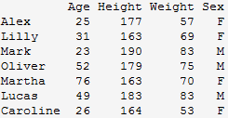](http://www.r-exercises.com/wp-content/uploads/2016/01/table1.png)*

Create the following vector: **Working = c(“Yes”, “No”,”No”,”Yes”,”Yes”,”No”,”Yes”)**

Create a new data frame adding **Working** as a column variable to the above data frame.

### Working with Rows

In “working with rows”, the two important features we want to demonstrate are sorting and filtering a data frame. We will show you two ways to filter: (a) using bracket notation and (b) using the subset( ) function. The bracket method is more programmable and flexible, but subset( ) is simpler. The bracket method is more fundamental to R, so let’s start with that one.

#### Filtering with Brackets

One rudimentary way to subset a data frame is with the bracket notation. ([https://www.r-bloggers.com/5-ways-to-subset-a-data-frame-in-r/](https://www.r-bloggers.com/5-ways-to-subset-a-data-frame-in-r/%20))

*Example 25:* Recreate the mydata2 data frame. Then use bracket notation to select the three individuals from Minnesota maintaining all columns (figure 33).

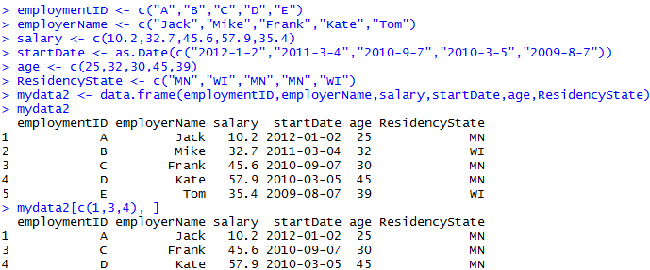

Figure 33. Filtering specific rows.

We used the vector (1,3,4) to specify the rows to keep. In a larger data frame, we usually would not know the row numbers in advance. So we need a way of generating those numbers formulaically. Recall the which( ) function from selecting specific columns. Now we want to select specific rows.

*Example 26:* Use the which( ) function to return the row numbers corresponding to the individuals that reside in Minnesota (figure 34).



Figure 34. Reminder how which( ) works.

The which( ) function returns the row numbers corresponding to the conditional statement provided. Notice the three numbers, 1, 3, and 4, match the row numbers we filtered earlier.

*Example 27:* Plug which( ) right into the brackets to select the three individuals from Minnesota (figure 35).

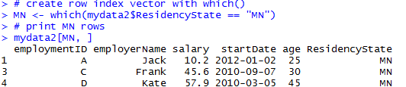

Figure 35. Select which( ) rows.

#### Filtering with subset( )

Let’s first take a look at the structure of the subset( ) function:

subset(x, subset, select, drop = FALSE, …)

x is the data frame, subset is a logical expression indicating the filter conditions, select is a vector of columns to keep. (<http://rprogramming.net/subset-data-in-r/>)

*Example 28:* Use the subset( ) function to select the individuals that reside in Minnesota (figure 36).

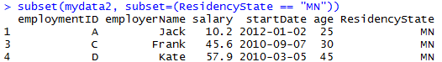

Figure 36. subset( ) data frames

A filter with many conditions is much more pleasant with subset( ) than with the bracket notation.

#### Sorting with order( )

When using row and column index numbers, order matters.

*Example 29:* Print the first three rows of the mydata2 data frame in natural order (1,2,3) (figure 37).

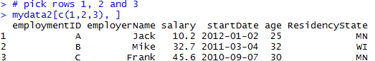

Figure 37. Rows in natural order.

*Example 30:* Now print the entire data frame in the following scrambled order: 1,3,2,5,4 (figure 38).

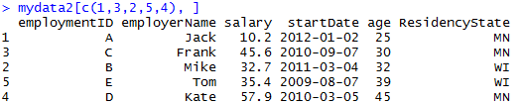

Figure 38. Rows in scrambled order.

This happens to sort the five individuals from youngest to oldest. Index numbers rule everything. So all we need is a function that returns index numbers in a desired order. That is the order( ) function. ([http://www.endmemo.com/program/R/order.php](http://www.endmemo.com/program/R/order.php%20))

*Example 31:* Use the order( ) function to return a vector of index numbers for the age variable (figure 39).



Figure 39. order( ) results for age.

In the mydata2 data frame, row 1 has the youngest individual, row 3 has the second youngest, and so on with row 4 having the oldest individual.

*Example 32:* Using the order( ) function, sort the mydata2 data frame by age (from youngest to oldest) (figure 40).

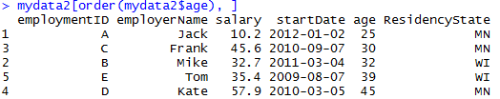

Figure 40. Using the order( ) function for sorting.

In sorting the data frame by age, we get rows 1, 3, 2, 5, and 4, in that order.

*Activity 7:* Consider the built-in data frame **chickwts**.

1. Create a subset of the data frame called **chickwts300p** which contains all observations for which the weight exceeds 300.
2. Create another subset called **chickwtsLinseed** which contains all observations for which the chicks were fed linseed.
3. Calculate the average weight of the chicks which were fed linseed.

### Adding New Observations to a Data Frame

New observations can be added to an existing data frame by first inserting the new observations in a data frame that contains the same variables and then using the rbind( ) function to join the two data frames together. The rbind( ) function merges two data frames “vertically” by binding the rows from them. The two data frames must have the same variables. ([http://www.endmemo.com/program/R/rbind.php](http://www.endmemo.com/program/R/rbind.php%20))

*Example 33:* Use the rbind( ) function to add the following two new observations to the existing mydata2 data frame (figure 41).

|  |  |  |  |  |  |
| --- | --- | --- | --- | --- | --- |
| Employment ID | Employer Name | salary | Start Date | age | ResidencyState |
| F | Andy | 46.9 | 2016-4-1 | 42 | MN |
| G | Beth | 51.2 | 2017-10-15 | 36 | MN |

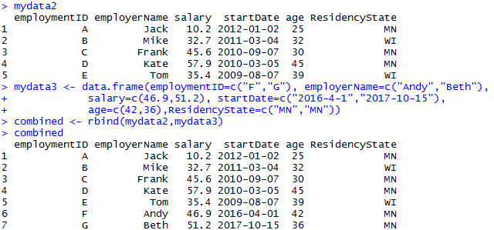

Figure 41. Combining of two data frames (mydata2 and mydata3) containing the same variables.

### Merging Data Frames

To merge two data frames that have the same cases but contain different variables, we accomplish this with the merge( ) function. In most cases, we want to merge the two data frames by one or more common key variables to make sure that the rows are matched correctly. The matching is controlled by the **by** optional argument which defaults to columns with names that are present in both data frames. ([https://www.statmethods.net/management/merging.html](https://www.statmethods.net/management/merging.html%20))

*Example 34:* We start by creating two example data frames (figure 42).

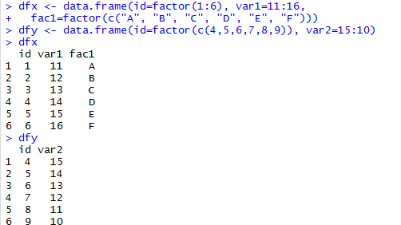

Figure 42. Creation of two data frames to be used to illustrate merging of data frames.

As demonstrated above, a shortcut for creating a vector is the : operator. 1:6 generates the sequence 1, 2, 3, 4, 5, 6 for the id variable in the dfx data frame. Likewise, 11:16 is equivalent to c(11, 12, 13, 14, 15, 16) for var1 and 15:10 is equivalent to c(15, 14, 13, 12, 11, 10) for var2.

There are four ways to merge two data frames: ([http://www.datasciencemadesimple.com/join-in-r-merge-in-r/](http://www.datasciencemadesimple.com/join-in-r-merge-in-r/%20))

* Inner join
* Outer join
* Left outer join
* Right outer join

#### Inner Join

An inner join only keeps the observations that are present in both data frames for the variable in the **by** argument.

*Example 35:* Merge the two data frames dfx and dfy by the id variable (figure 43).

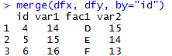

Figure 43. Example of inner join merge.

Note how the unmatched observations from dfx and dfy are discarded from the merged data frame since the id does not appear in both data frames.

#### Outer Join

The outer join keeps all the observations from both data frames (corresponding to the union of all observations for the variable in the **by** argument). Setting the all=TRUE argument includes all observations from both data frames.

*Example 36:* Merge the two data frames dfx and dfy by the id variable with the all=TRUE argument (figure 44).

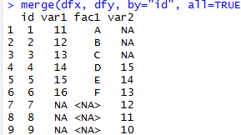

Figure 44. Example of outer join merge.

#### Left Outer Join

A left outer join keeps all observations and variables from the “left” data frame and adds the variables from the “right” data frame if they have a corresponding match for the values from the **by** variable. A left outer join is undertaken with the all.x=TRUE argument.

*Example 37:* Merge the two data frames dfx and dfy by the id variable with the all.x=TRUE argument (figure 45).

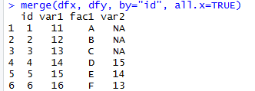

Figure 45. Example of left outer join merge.

#### Right Outer Join

A right outer join is the opposite of a left outer join and ensures that all the rows from the second data frame are always kept in the merged data frame. Observations from the left data frame are only included if they have a corresponding match in the right data frame for the **by** variable values. Setting the all.y=TRUE argument forces a right outer join.

*Example 38:* Merge the two data frames dfx and dfy by the id variable with the all.y=TRUE argument (figure 46).

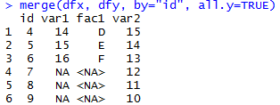

Figure 46. Example of right outer join merge.

Note that NA is inserted for all the outer joins variables when only a row or id only appear in one of the two data frames.

*Activity 8:* Create a data frame (call it **born**) from the table below:

|  |  |  |
| --- | --- | --- |
| name | year.born | place.born |
| Moe | 1887 | Bensonhurst |
| Larry | 1902 | Philadelphia |
| Curly | 1903 | Brooklyn |
| Harry | 1964 | Moscow |

Create a second data frame (call it **died**) from the following table:

|  |  |
| --- | --- |
| name | year.died |
| Curly | 1952 |
| Moe | 1975 |
| Larry | 1975 |

Perform an inner merge on the two data frames by using **name** to combine matched rows.

### Stacking the Columns of a Data Frame Together

Observations from different groups, situations, or conditions are sometimes stored as separate variables in a data frame. The stack( ) function takes the individual columns and transforms them into a new data frame. By default, stack( ) stacks all the numeric variables into a new variable called values and includes a column, ind, that contains the column name corresponding to the column in the original data frame that provided the value. ([http://www.datasciencemadesimple.com/stack-and-unstack-function-in-r/](http://www.datasciencemadesimple.com/stack-and-unstack-function-in-r/%20))

*Example 39:* After creating a data frame, use the stack( ) function to transform the columns into a single vector (figure 47).

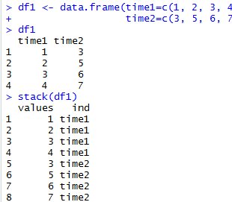

Figure 47. Example of stacking data frame columns.

The function unstack( ) reverses the stack( ) function.

### Transforming a Variable

It is often necessary to create a new variable based on the existing variable(s) or to transform a variable, for example to change its scale. The transform( ) function can be used to create a new data frame from an existing data frame and at the same time define or redefine variables inside the new data frame. As its first argument transform( ) takes the name of an existing data frame, and changed variables are put as additional arguments of the form tag=value as shown in example 40. ([http://www.endmemo.com/program/R/transform.php](http://www.endmemo.com/program/R/transform.php%20))

*Example 40:* Using the airquality data frame in base R, create a new data frame which includes the log transformation of the Ozone variable from the original data frame (figure 48).

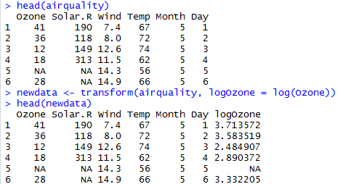

Figure 48. Example of variable transformation.

*Activity 9:* Using the **BOD** data frame in base R, create a new data frame which includes the square root (**sqrt( )** function in R) of the **demand** variable from the **BOD** data frame.

### Logical Operations

In examples 20, 21, 26, 27, and 28, we used the symbol ==. This is an example of a logical operator. In R, == means ‘exactly equal to.’ All logical operators are expressions that return TRUE or FALSE. For instance in examples 26, 27, and 28, we used == to select all individuals where ResidencyState was exactly equal to MN (ResidencyState == “MN”). Table 4 provides a list of common logical operators in R. ([https://www.datamentor.io/r-programming/operator](https://www.datamentor.io/r-programming/operator%20))

|  |  |
| --- | --- |
| **Operator** | **Description** |
| < | Less than |
| <= | Less than or equal to |
| > | Greater than |
| >= | Greater than or equal to |
| == | Exactly equal to |
| != | Not equal to |
| !x | Not x |
| x | y | x or y |
| x & y | x and y |
| isTRUE(x) | Tests whether x is TRUE |

*Example 41:* Create two vectors, x and y, of equal length. Using logical operators perform the following elementwise comparisons: x < 5, x > y, and x < y (figure 49).

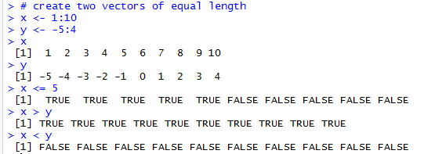

Figure 49. Example of the use of logical operators.

Is x less than or equal to 5? The answer is yes for the first five values (1, 2, 3, 4 and 5) and no for the last five (6, 7, 8, 9 and 10). Likewise, 1 > -5, 2 > -4, …, 10 > 4. So x > y for all elementwise comparisons. Hence x > y returns TRUE for all 10 comparisons. In contrast, x < y returns FALSE for each of the comparisons.

*Example 42:* Use logical operators to compare the following expressions: (a) Does 2 equal 3?; (b) Does 2 not equal 3?; (c) Is 2 less than 3?; (d) Is 2 less than or equal to 3?; (e) Is 2 greater than 3?; (f) Is 2 greater than or equal to 3? (figure 50)

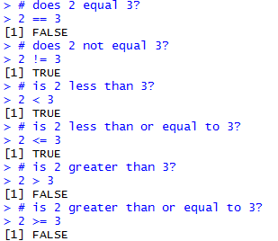

Figure 50. Using logical operators to compare two numbers.

To test whether all the resulting elements are TRUE, use the all( ) function. Similarly, the any( ) function checks whether any element is TRUE. ([http://www.datasciencemadesimple.com/any-and-all-function-in-r/](http://www.datasciencemadesimple.com/any-and-all-function-in-r/%20))

*Example 43:* Create two vectors, x and y, of equal length. Use the any( ) and all( ) functions on the expression x < y (figure 51).

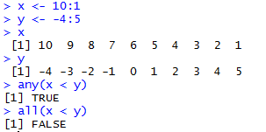

Figure 51. Illustration of the use of the any( ) and all( ) functions.

### Logical Arithmetic

Arithmetic involving logical expressions is very useful in programming and in selection of variables. The key thing to understand is that logical expressions evaluate to either true or false (represented in R by TRUE or FALSE). Numerically, TRUE is the same as 1 and FALSE is the same as 0.

*Example 44:* Calculate the following: TRUE * 5 and FALSE * 5 (figure 52).



Figure 52. Logical arithmetic where TRUE = 1 and FALSE = 0.

Since TRUE = 1, TRUE * 5 = 5; also since FALSE = 0, FALSE * 5 = 0.

R provides T and F as shortcuts for TRUE and FALSE, respectively, but it is best practice not to use them, as they are simply variables storing the values TRUE and FALSE and can be overwritten as seen in example 45.

*Example 45:* Check the default value of T and then see what happens when T is assigned a numerical value (figure 53).

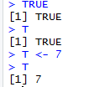

Figure 53. Demonstration of why T should not be used as a shortcut for TRUE.

*Activity 10:* Calculate the expression (**TRUE + TRUE) * FALSE**.

### Missing Data

In examples 36, 37 and 38 on merging data frames, we saw the expression NA inserted for some variables due to missing values. NA is entered simply by typing the letters “N” and “A” as if they were normal text. NA will often be seen as just another element of a vector. is.na( ) tests each element of a vector for missingness. ([https://www.statmethods.net/input/missingdata.html](https://www.statmethods.net/input/missingdata.html%20))

*Example 46:* Use the function is.na( ) on the vector c(1, 2, NA, 8, 3, NA, 3) (figure 54).

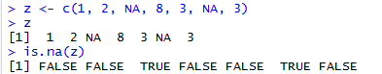

Figure 54. Use of the is.na( ) function.

*Example 47:* Calculate the mean of z from example 46 (figure 55).



Figure 55. Calculation of the mean for a vector which includes NA elements.

The answer is NA since mean returns NA if even a single element is NA.

In order to calculate the mean of the non-missing values in example 47, you need to specify that the NA are to be removed, using the na.rm=TRUE argument. There is similar functionality with sum, min, max, var, sd and other functions.

*Example 48:* Calculate the mean of z from examples 46 and 47 after removing the missing data (figure 56)

.

Figure 56. Calculation of the mean after removing the missing data values.

When the na.rm is TRUE, mean first removes the missing data, then calculates the mean.

NA works for any kind of vector.

*Example 49:* Use the function is.na( ) on the vector c(“Football”, NA, “Soccer”) (figure 57).

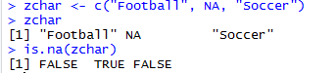

Figure 57. Use of the is.na( ) function on non-numerical data.

*Activity 11:* Consider the following vector **A <- c (33, 21, 12, NA, 7, 8)**.

Calculate the mean of A without the missing value.

### Developing Functions

Much of what we need from R can be done with built-in functions or functions that come in the libraries we install. But sometimes we are doing something so specific that we are best off writing our own functions. Or sometimes we need to repeat a specific task within a program and would rather not copy and paste the same code over and over.

The descriptive anatomy of a custom function is as follows:

functionname <- function(argument1, argument2, …, argument) {

<< commands using the supplied arguments >>

return(output)

}

(<https://swcarpentry.github.io/r-novice-inflammation/02-func-R/>)

Creating a function is just like creating any other object. You name it on the left hand side, and define it on the right hand side. You can specify as many arguments as you wish. Within the braces, we run commands and can reference argument 1 through argument N as needed. And finally, the function will return whatever is in the return( ) function. If no return( ) is specified, the function will simply return the last command before the closing brace.

*Example 50:* Create a function to calculate the arithmetic mean of a single sample. Test the function with some data where we know the right answer, c(3, 3, 4, 5, 5) (figure 58).



Figure 58. Creation of a function to calculate the arithmetic mean of a single sample.

*Example 51:* Create a function to calculate the sample variance of a single sample. Use the function to calculate the variance for the following sample: c(13, 7, 5, 12, 9, 15, 6, 11, 9, 7, 12) (figure 59).



Figure 59. Creation of a function to calculate the sample variance.

In example 51, mean(x) and length(x) are built-in functions for calculating the arithmetic mean and determining the sample size, respectively.

*Example 52:* R does not have a built-in function for calculating the coefficient of variation. Use the built-in functions mean(x) and sd(x) to create a function to calculate the coefficient of variation. Use the function to calculate the coefficient of variation for the vector consisting of the first 10 positive integers (figure 60).



Figure 60. Creation of a function to calculate the coefficient of variation.

The first line creates a function and assigns it to cv. The second line invokes the function, using 1:10 for the value of parameter x. The function returns the value of its single-expression body, sd(x)/mean(x).

A multiline function uses curly braces to delimit the start and end of the function body. Also you can refer to functions from within other functions. A confidence interval (CI) for the population mean is sample mean (Student’s -value) (standard error of the mean).

*Example 53:* There is no built-in R function to calculate the standard error of a mean. Write a function to do so (figure 61).



Figure 61. Creation of a function to calculate the standard error of a mean.

The R function qt gives the value of Student’s with 1 /2 = 0.975 and degrees of freedom d.f. = length(x) – 1.

*Example 54:* Create a function called ci95 which uses the function se from example 53 to compute 95% confidence intervals for a mean. Test the function with 150 normally distributed random numbers with mean 25 and standard deviation 3 (figure 62).

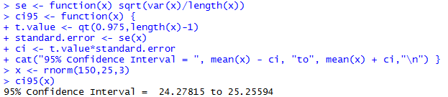

Figure 62. Example of a multiline function.

*Activity 12:* Create a function that will return the sum of two integers.

### If-else Statement in R

#### If Statement

The conditional statement in R programming is shown by the syntax of if statement below:

if (condition_expression) {

statement

}

If the condition_expression is TRUE, then the statement gets executed. If the condition_expression is FALSE, nothing happens. The condition_expression can be a logical or numeric vector. In the case of numeric vector, zero is taken as FALSE, rest as TRUE. The flowchart of if statement is shown in figure 63 (source: <https://www.datamentor.io/r-programming/if-else-statement>).

Condition Expression

True

Statement

False

Figure 63. Flowchart of if statement in R

*Example 55*: Enter a number from the terminal (in interactive use). If the number entered is positive, print that number.

x=readline(“Please enter a number”)

After this command, R prompts to a line starting with “Please enter a number”. Then you need to enter a number, and that number is assigned to x.

if(x>0) {

print(x) }

#### If-else Statement

The syntax of if-else statement is

if (condition_expression) {

statement1

} else if (condition_expression) {

statement2

} else if (condition_expression) {

statement3

} else {

statement4

}

You can include as many conditions as you may. It is important to note that else must be in the same line as the closing braces of the if statement. The last else statement is optional. The flowchart of if-else statement is shown in figure 64.

if Condition Expression

True

Statement

False

Statement

else if Condition Expression

True

**…**

Figure 64. Flowchart of if-else statement

*Example 56*: Suppose a client pays you a unit price for a job. You would like to give him a discount of 10% off if he offers you more than 100 hours but less than 200 hours of work. You give him an extra discount of another 10% off the discounted price if he offers you more than 200 hours of work. Use if-else statement and create an R function to calculate the payment. Use the function to find the price of working for 120 hours with the unit price of $20/hour

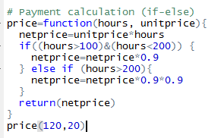

*Activity 13*: Suppose you own stocks and make decisions based on the average price of the previous three days. Here is how you make your decisions:

* If the stock value today is lower than the average value of previous three days, you buy
* If the stock value today is higher than the average value of previous three days, you sell
* If the stock value today is the same as the average of previous three days, you watch

Write an R function including the if-else statement to return the decision.

### Repetitive Execution: for loops, repeat and while

Loops are powerful tool that will let us repeat operations. For example, we can do something to every row of our data frame.

#### For Loop

The syntax of a for loop is

for (variable in vector) {

statement

}

The for loop structure does the same thing for n times. The expression in the parenthesis (variable in vector) is the criteria of making the decision of doing the thing or not. The variable in the expression is referred as indicator. If the variable value is in the range of the vector, the expression returns TRUE, and the loop is executed. If the variable value is not in the range of the vector, the expression returns FALSE, and the loop is stopped. At the end of each loop, the indicator is increased by 1.

*Example 57*: Let x be a vector from 0 to 5. Use for loop to print values

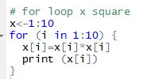

*Activity 14:* Find the sum of the first 100 squares: is from 0 to 100, and calculate the sum of .

#### While Loop

The syntax of the while loop in R is

while (condition_expression)

{

statement

}

The condition_expression is evaluated and the body of the loop is entered if the result is TRUE. The statement inside of the loop is executed and the flow returns to evaluate the condition_expression again. This is repeated each time until the condition_expression evaluates to FALSE, in which case, the loop exists.

The flowchart of the while loop is shown in figure 65.

Condition Expression

Statements

True

False

Exit Loop

Figure 65. Flowchart of the while loop

*Example 58*: Find the sum of squares for x<10. The initial value of x is 0.

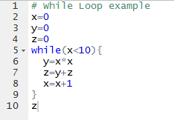

*Activity 15:* Let the initial value of x be 0. Print the values until x is 10 (not including 10).

#### Repeat loop

A repeat loop is used to iterate over a block of code multiple number of times. There is no condition to check in repeat loop to exit the loop. We include a condition explicitly inside the body of the loop and use the break statement to exit the loop.

The syntax of the repeat loop is

repeat {

statement

if (condition_expression) {

break

}  
}

The flowchart of repeat loop is shown in figure 66.

Statements

Check break condition

False

True

Exit Loop

Keep doing the statements

Figure 66. Flowchart of repeat loop

*Example 59*: Use repeat loop to find the sum of squares for x<10. The initial value of x is 0.

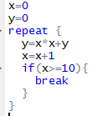

*Activity 16*: Use repeat loop to print values until x reaches 10, including 10. Let the initial value of x be 0.

### Debug

There are various options which can be useful to debug a function and find an error. A useful debugging function in R is the function browser(). If you insert the instruction browser() in the source of your function, the program will stop a the place where it was inserted.

*Example 60:*

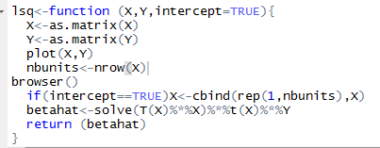

Run the function and find the intercept for the following X and Y:

X=matrix(c(1,2,3,4,5,6,7,8,9), nrow=3,byrow=TRUE)

Y=matrix(c(3,2,1,4,6,5,9,8,7), nrow=3, byrow=TRUE)

lsq(X,Y)

While running the code, you can see that it stopped at the browser() (figure 67). Then the program started to debug line by line until it found an error

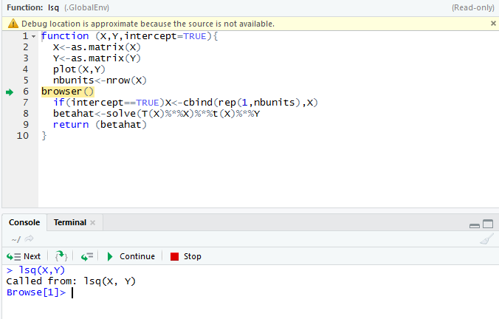

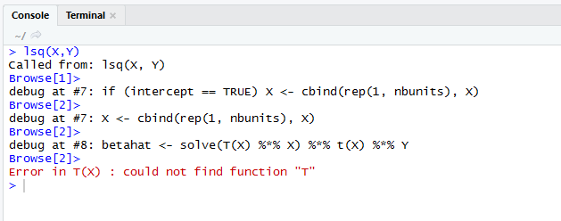

Figure 67. Debug using browser().

Here the error message shows that “could not find function T” because the transpose function is the lower-case t(X).

Another interesting function is debug() which is equivalent to putting the instruction browser() at the top of a function.

*Example 61*: If we put debug (var) at the top of the function var(1:3), it marks the function var as debuggable and debug each line of the function code (figure 68). At the end of the debug, you need to end the process of debug by using the function undebug(), otherwise, R will put the function var() as debuggable each time you run it.

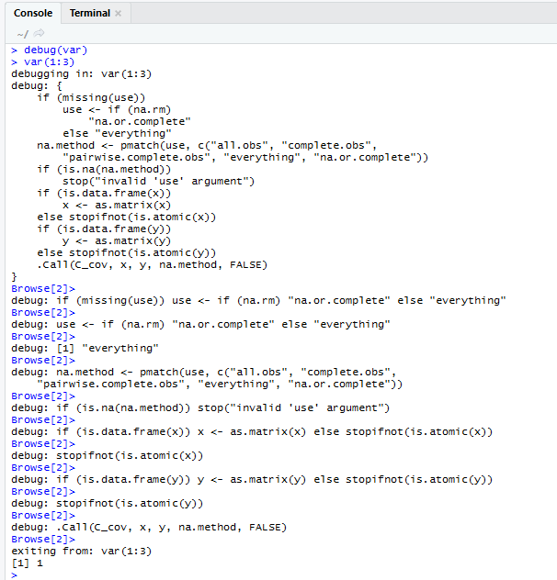

Figure 68. Debug using debug() and undebug().

### Data Types

As we have seen in the creation of vectors and data frames, there are numerous data types in R that store various kinds of data. The four main types of data most likely to be used are:

* numeric
* character (string)
* Date/POSIXct (time-based)
* logical (TRUE/FALSE)

The type of data contained in a variable is checked with the class( ) function. ([http://rfunction.com/archives/770](http://rfunction.com/archives/770%20))

*Example 62:* Assign a number to a variable and use the class( ) function to check that it is numeric (figure 769).



Figure 69. Use of the class( ) function.

#### Numeric Data

Numeric data is the most common type in R. The most commonly used numeric data is **numeric**. This is similar to a float or double in other languages. It handles integers and decimals, both positive and negative, and zero. A numeric value stored in a variable is automatically assumed to be **numeric**. Testing whether a variable is **numeric** is done with the function is.numeric( ). (<https://stat.ethz.ch/R-manual/R-patched/library/base/html/numeric.html>)

*Example 63:* Use the is.numeric( ) function to verify that the variable defined in example 62 is **numeric** (figure 70).



Figure 70. Use of the is.numeric( ) function.

Another important, if less frequently used, type is **integer**. As the name implies, this is for whole numbers only, no decimals. To set an integer to a variable it is necessary to append the value with an L. As with checking for a **numeric**, the is.integer( ) function is used. ([http://www.r-tutor.com/r-introduction/basic-data-types/integer](http://www.r-tutor.com/r-introduction/basic-data-types/integer%20))

*Example 64:* Assign an integer value to a variable. Use the is.integer( ) function to verify that the variable is an integer (figure 71).

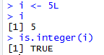

Figure 71. Creation of an integer variable and verification with the is.integer( ) function.

Even though i is an **integer**, it will also pass a **numeric** check.

*Example 65:* Use the is.numeric( ) function to verify that the variable defined in example 64 passes a **numeric** check (figure 72).



Figure 72. Verification that a variable assigned as an integer also passes the is.numeric( ) check.

R nicely promotes **integers** to **numeric** when needed. This is obvious when multiplying an **integer** by a **numeric**, but importantly it works when dividing an **integer** by another **integer**, resulting in a decimal number.

*Example 66:* Identify the class for the values 4 and 2.8. Determine the class of the product of these two numbers. Find the class for the values 2 and 5 and for the quotient of 5 divided by 2 (figure 73).

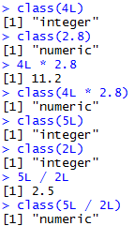

Figure 73. Classes of products and quotients involving integers.

#### Character Data

Even though it is not explicitly mathematical, the character (string) data type is very common in statistical analysis and must be handled with care. R has two primary ways of handling character data: **character** and **factor**. While they may seem similar on the surface, they are treated quite differently. ([http://www.r-tutor.com/r-introduction/basic-data-types/character](http://www.r-tutor.com/r-introduction/basic-data-types/character%20)) ([https://www.dummies.com/programming/r/how-to-convert-a-factor-in-r/](https://www.dummies.com/programming/r/how-to-convert-a-factor-in-r/%20))

*Example 67:* Assign the string “data” to the variable x and factor(“data”) to the variable y (figure 74).

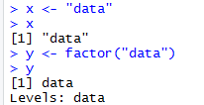

Figure 74. Differences in treatment of **character** and **factor** data.

Notice that x contains the word “data” encapsulated in quotes, while y has the word “data” without quotes and a second line of information about the **levels** of y.

Characters are case sensitive, so “Data” is different from “data” or “DATA”.

To find the length of a **character** (or **numeric**) use the nchar( ) function. ([http://www.endmemo.com/program/R/nchar.php](http://www.endmemo.com/program/R/nchar.php%20))

*Example 68:* Use the nchar( ) function on the following: x from example 67, the string “hello”, the values 3 and 452, and y from example 67 (figure 76).

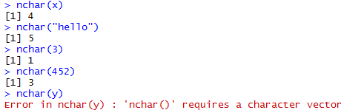

Figure 75. Examples of the use of the nchar( ) function.

Note that nchar( ) function does not work for **factor** data.

#### Dates

R has numerous different types of dates. The most useful are Date( ) and POSIXct( ). Date( ) stores just a date while POSIXct( ) stores a date and time. Both objects are actually represented as the number of days (Date( )) or seconds (POSIXct( )) since January 1, 1970. ([https://www.stat.berkeley.edu/~s133/dates.html](https://www.stat.berkeley.edu/~s133/dates.html%20))

*Example 69:* Define a variable date1 using the as.Date( ) function. Use the class( ) function on date1. Determine the number of days since January 1, 1970 by use of the as.numeric( ) function. Then define a variable date2 with the as.POSIXct( ) function. Use the class( ) function on date2. Finally, calculate the number of seconds since January 1, 1970 with use of the as.numeric( )function (figure 76).

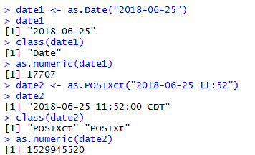

Figure 76. Use of the as.Date( ) and as.POSIXct( ) functions.

Using functions such as as.numeric( ) or as.Date( ) does not merely change the formatting of an object but actually changes the underlying type.

*Example 70:* In example 69, we saw that the class( ) function applied to the variable date1 returned the “Date” data type. Also the as.numeric( ) function returned the number of days between January 1, 1970 and June 25, 2018. Apply the class( ) function to as.numeric(date1) (figure 77).



Figure 77. Example of a change in the data type of an object.

#### Logical

**Logicals** are a way of representing data that can be either TRUE or FALSE. Numerically, TRUE is the same as 1 and FALSE is the same as 0. So TRUE * 5 equals 5 while FALSE * 5 equals 0 (see example 44).

Similar to other types, **logicals** have their own test, using the is.logical( ) function. ([https://www.rdocumentation.org/packages/base/versions/3.5.0/topics/logical](https://www.rdocumentation.org/packages/base/versions/3.5.0/topics/logical%20))

*Example 71:* Assign TRUE to a variable. Then use the functions class( ) and is.logical( ) on the variable (figure 78).

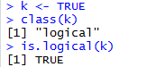

Figure 78. Example of a logical data type variable.

*Activity 17:* Convert 02/07/10, 02/23/10, 02/08/10, 02/14/10, and 02/10/10 into date objects within the variable, **Activity17Dates**.

### Summary Statistics

Some of the most common tools used in statistics and data science are means, variances, and standard deviations. They are all well represented in R with easy-to-use functions.

The first thing many people think of in relation to statistics is the average, or mean, as it is properly called. First we generate a random sampling of 100 numbers between 1 and 100.

*Example 72:* Use the sample( ) function to generate a random sample of 100 numbers between 1 and 100 (figure 80). ([http://www.datasciencemadesimple.com/sample-function-in-r/](http://www.datasciencemadesimple.com/sample-function-in-r/%20))

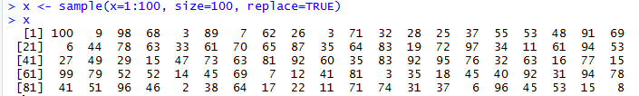

Figure 80. Use of the sample( ) function to generate a random sample of size 100.

The sample( ) function uniformly draws size( ) entries from x. Setting replace=TRUE means that the same number can be drawn multiple times.

Now that we have a vector of data we can calculate the mean (figure 81). (<http://www.endmemo.com/program/R/mean.php>)



Figure 81. Use of the mean( ) function.

This is the simple arithmetic mean. We need to consider cases where some data is missing. To create this we take x and randomly set 20 percent of the elements to NA.

*Example 73:* Make a copy of x assigning it to variable y. Then choose a random sample of 20 elements to set to NA (figure 82).

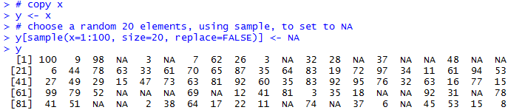

Figure 82. Setting of 20 random elements in a sample to NA.

Using mean( ) on y will return NA (figure 83). This is because, by default, if mean( ) encounters even one element that is NA it will return NA.



Figure 83. Use of the mean( ) function on a sample containing NA elements.

To have the NAs removed before calculating the mean, set na.rm to TRUE (figure 84).



Figure 84. Removal of NAs before calculation of the mean.

To calculate the weighted mean of a set of numbers, the function weighted.mean( ) takes a vector of numbers and a vector of weights. It also has an optional argument, na.rm, to remove NAs before calculating; otherwise, a vector with NA values will return NA. ([http://astrostatistics.psu.edu/su07/R/html/stats/html/weighted.mean.html](http://astrostatistics.psu.edu/su07/R/html/stats/html/weighted.mean.html%20))

*Example 74:* Find the arithmetic mean and weighted mean of the following student scores: 85, 82, 77, 76 with respective weights of 1/8, 1/8, 1/4, 1/2 (figure 85).

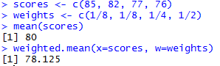

Figure 85. Comparison of calculating the arithmetic mean and a weighted mean.

Another vitally important metric is the variance, which is calculated with var( ) (figure 86). (<http://www.r-tutor.com/elementary-statistics/numerical-measures/variance>)



Figure 86. Use of the var( ) function to calculate the sample variance.

*Example 75:* Refer to example 51. Verify that var( ) calculates the sample variance (figure 87).



Figure 87. Verification that var(x) calculates the sample variance.

Standard deviation is the square root of variance and is calculated with sd( ). Like mean( ) and var( ), sd( ) has the na.rm argument to remove NAs before computation; otherwise, any NAs will cause the answer to be NA (figure 88). (<http://www.r-tutor.com/elementary-statistics/numerical-measures/standard-deviation>)

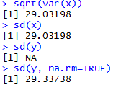

Figure 88. Use of the sd( ) function.

Other commonly used functions for summary statistics are min( ), max( ) and median( ). All of these also have na.rm arguments (figure 89). (<http://www.endmemo.com/program/R/max.php>) (<http://www.r-tutor.com/elementary-statistics/numerical-measures/median>)

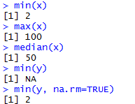

Figure 89. Use of the min( ), max( ), and median( ) functions.

A helpful function that computes the mean, minimum, maximum and median is summary( ). There is no need to specify na.rm if there are NAs, they are automatically removed and their count is included in the results (figure 90). (<http://www.endmemo.com/program/R/summary.php>)

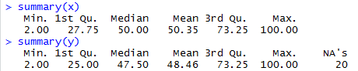

Figure 90. Use of the summary( ) function.

The summaries also displayed the first and third quartiles. These can also be computed using the quantile( ) function (figure 91). Quantiles are numbers in a set where a certain percentage of the numbers are smaller than that quantile. ([http://www.r-tutor.com/elementary-statistics/numerical-measures/quartile](http://www.r-tutor.com/elementary-statistics/numerical-measures/quartile%20) )

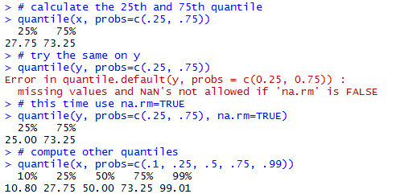

Figure 91. Use of the quantile( ) function.

*Activity 18:* Using the **chickwts** data frame, compute the 10th, 30th, and 90th percentiles of all the chick weights.

### Matrices

A very common mathematical structure that is essential to statistics and data science is a matrix (see example 60). This is similar to a data frame in that it is rectangular with rows and columns except that every single element, regardless of column, must be the same type, most commonly all **numerics**. They also act similarly to vectors with element-by-element addition, multiplication, subtraction, division and equality.

#### Creating a Matrix

There are several ways of making a matrix. You can create one directly as in the next example. ([http://www.r-tutor.com/r-introduction/matrix/matrix-construction](http://www.r-tutor.com/r-introduction/matrix/matrix-construction%20))

*Example 76:* Create the 3 x 3 identity matrix (that is, with 1’s along the diagonal and 0’s as the off-diagonal elements) (figure 91).

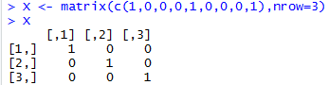

Figure 91. Creation of the 3 x 3 identity matrix.

By default, the numbers are entered column-wise. The class and attributes of X indicate that it is a matrix of three rows and three columns (these are its dim( ) attributes) (figure 92).

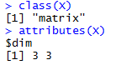

Figure 92. class( ) and attribute( ) function applied to the 3 x 3 identity matrix.

The nrow( ), ncol( ) and dim( ) functions work just like they do for data frames (figure 93).

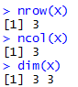

Figure 93. nrow( ), ncol( ) and dim( ) functions applied to the 3 x 3 identity matrix.

In the next example, the data in the vector appear row-wise, so we indicate this with byrow=T. ([http://www.r-tutor.com/r-introduction/matrix](http://www.r-tutor.com/r-introduction/matrix%20))

*Example 77:* From the vector, c(1, 2, 3, 4, 4, 3, 2, 1), create a 2 x 4 matrix where the first row consists of the elements 1, 2, 3, and 4 while the second row is made up of 4, 3, 2, and 1 (figure 94).

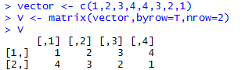

Figure 94. Creation of a 2 x 4 matrix using byrow=T.

Another way to convert a vector into a matrix is by providing the vector object with two dimensions (rows and columns) using the dim( ) function (figure 95).

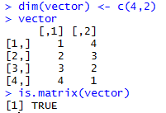

Figure 95. Creation of a matrix using the dim( ) function on a vector object.

The is.matrix( ) function checks that vector has now become a matrix. ([https://stat.ethz.ch/R-manual/R-devel/library/base/html/matrix.html](https://stat.ethz.ch/R-manual/R-devel/library/base/html/matrix.html%20))

We need to be careful, however, because we have made no allowance at this stage for the fact that the data were entered row-wise into vector. As figure 95 shows, a 4 x 2 matrix has been created since R assumes a default of column-wise entry. The matrix we want is the transpose, t, of this matrix (figure 96). ([https://www.dummies.com/programming/r/how-to-do-matrix-arithmetic-in-r/](https://www.dummies.com/programming/r/how-to-do-matrix-arithmetic-in-r/%20))



Figure 96. Creation of the transpose of a matrix.

*Activity 19:* Construct a 4 x 2 matrix that’s filled row-wise with the values 4.3, 3.1, 8.2, 8.2, 3.2, 0.9, 1.6, and 6.5, in that order.

#### Matrix Properties

The determinant of a 2 x 2 matrix can be calculated as . For larger square matrices, the calculation becomes more complicated. It can be found in R using the det( ) function. ([http://www.endmemo.com/program/R/det.php](http://www.endmemo.com/program/R/det.php%20))

*Example 78:* Hilbert matrices are often studied in numerical linear algebra. Construct the 3 x 3 Hilbert matrix, where entry () is 1 / (). Then use the det( ) function to find the determinant (figure 97).

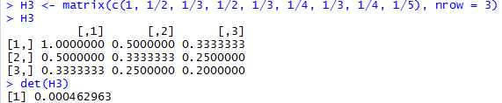

Figure 97. Use of the det( ) function.

Note that ncol is not required in the command that created it, since the data argument has been assigned a vector consisting of nine elements; it is clear that if there are three rows there must also be three columns.

The diagonal elements can be obtained using the diag( ) function (figure 98). ([http://www.endmemo.com/program/R/diag.php](http://www.endmemo.com/program/R/diag.php%20))



Figure 98. Use of the diag( ) function.

We can then compute the trace (the sum of the diagonal entries) using a home-made function (figure 99).



Figure 99. Creation of a function to calculate the trace of a matrix.

Applying this function to the 3 x 3 Hilbert matrix, we obtain figure 100.



Figure 100. Calculation of the trace of a matrix using the function from figure 99.

The diag( ) function can also be used to turn a vector into a square diagonal matrix whose diagonal elements correspond to the entries of the given vector (figure 101).

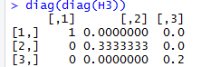

Figure 101. Use of the diag( ) function to create a square diagonal matrix.

As in figure 96, the t( ) function is used to calculate the matrix transpose (figure 102).

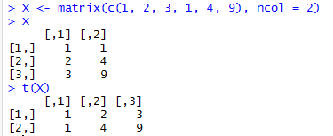

Figure 102. Use of t( ) to calculate the matrix transpose.

#### Matrix Arithmetic

Multiplication of a matrix by a scalar constant is the same as multiplication of a vector by a constant. ([http://www.johnmyleswhite.com/notebook/2009/12/16/quick-review-of-matrix-algebra-in-r/](http://www.johnmyleswhite.com/notebook/2009/12/16/quick-review-of-matrix-algebra-in-r/%20))

*Example 79:* Use the X matrix from figure 102 and multiply each element by 2 (figure 103).

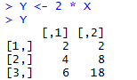

Figure 103. Multiplication of a matrix by a scalar constant.

Elementwise addition of matrices also proceeds as for vectors (figure 104).

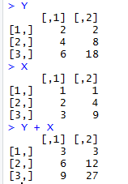

Figure 104. Elementwise addition of matrices.

When adding matrices, always ensure that the dimensions match properly. If they do not match correctly, an error message will appear (figure 105).

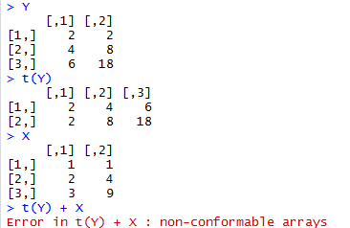

Figure 105. Attempted addition of matrices where dimensions do not match.

In figure 105, YT is a 2 x 3 matrix while X is 3 x 2.

The command X * Y performs elementwise multiplication (figure 106).

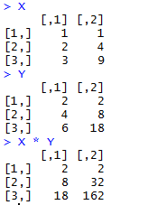

Figure 106. Elementwise multiplication of matrices.

This differs from the usual form of matrix multiplication that we will discuss in the next section. Again, in order for this kind of multiplication to work, the dimensions of the matrices must match.

#### Matrix Multiplication

If A and B are matrices, then the matrix product AB is the matrix representing the composition of the two operations: first apply B, then apply A to the result. For matrix multiplication to be a properly defined operation, the matrices to be multiplied must conform. That is, the number of columns of the first matrix must match the number of rows of the second matrix. The resulting matrix AB will have its row dimension taken from A and its column dimension taken from B.

In R, this form of matrix multiplication can be performed using the operator %*%. ([http://philender.com/courses/multivariate/notes/matr.html](http://philender.com/courses/multivariate/notes/matr.html%20))

*Example 80:* Using the operator %*%, multiply the transpose of the matrix Y (figure 103) by the matrix X (figure 102) (figure 107).

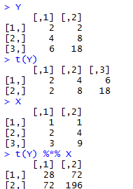

Figure 107. Matrix multiplication using the operator %*%.

t(Y) has three columns and X has three rows, so we can perform the multiplication YTX. The result is a 2 x 2 matrix, since t(Y) has two rwos and X has two columns.

If we failed to transpose Y, we would obtain an error, as in figure 108.



Figure 108. Error message for multiplying matrices that do not conform.

#### Calculations on Rows or Columns of the Matrix

We could use subscripts to select parts of the matrix, with a blank meaning ‘all of the rows’ or ‘all of the columns’.

*Example 81:* Create a 4 x 5 matrix using the following code: X <- matrix(c(1, 1, 3, 1, 0, 1, 1, 0, 2, 3, 0, 2, 5, 1, 2, 1, 3, 3, 2, 0)). Then find the mean of the rightmost column (number 5), calculated over all the rows (blank then comma). Also find the variance of the bottom row, calculated over all of the columns (a blank in the second position). (figure 109)

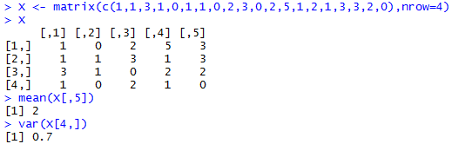

Figure 109. Calculation of the mean of column 5 and the variance of row 4.

There are some special functions for calculating summary statistics on matrices (figure 110). ([http://www.datasciencemadesimple.com/rowsums-colsums-rowmeans-columnmeans-r/](http://www.datasciencemadesimple.com/rowsums-colsums-rowmeans-columnmeans-r/%20))

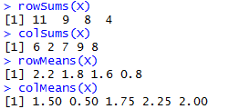

Figure 110. Matrix summary statistics: row and column sums and means.

The apply( ) function is used for applying functions to the rows or columns of matrices or data frames. Often you want to apply a function across one of the margins of a matrix. Margin 1 refers to the rows and margin 2 to the columns. ([https://www.r-bloggers.com/r-tutorial-on-the-apply-family-of-functions/](https://www.r-bloggers.com/r-tutorial-on-the-apply-family-of-functions/%20))

*Example 82:* Use the apply( ) function to find the row totals (four of them) and the column totals (five of them) of the X matric from example 81 (figure 111).



Figure 111. Use of the apply( ) function to find row and column totals.

Note that in both cases, the answer produced by apply( ) is a vector rather than a matrix. You can apply( ) functions to the individual elements of the matrix rather than to the margins. The margin you specify influences only the shape of the resulting matrix. (figure 112)

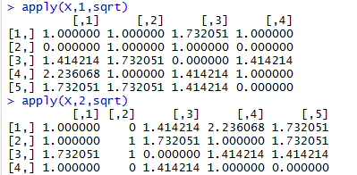

Figure 112. Use of the apply( ) function on the individual elements of a matrix.

#### Adding Rows and Columns to the Matrix

Assume we have been asked to add a row at the bottom showing the column means, and a column at the right showing the row variances (figure 113). ([http://www.r-tutor.com/r-introduction/matrix/matrix-construction](http://www.r-tutor.com/r-introduction/matrix/matrix-construction%20))

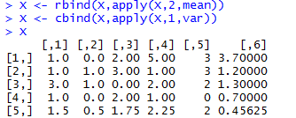

Figure 113. Addition of row 5 (column means) and column 6 (row variances).

Note that the number of decimal places varies across columns, with one in columns 1 and 2, two in columns 3 and 4, none in column 5 (integers) and five in column 6. The default in R is to print the minimum number of decimal places consistent with the contents of the column as a whole.

Next, we need to label the sixth column as ‘variance’ and the fifth row as ‘mean’ (figure 114). ([https://www.dummies.com/programming/r/r-for-dummies-cheat-sheet/](https://www.dummies.com/programming/r/r-for-dummies-cheat-sheet/%20))

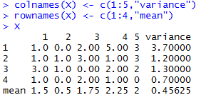

Figure 114. Labeling of rows and columns of a matrix.

*Activity 20:* Create the following four matrices:

, , , and .

1. Calculate .
2. Calculate
3. Calculate 3.
4. Calculate using %*%
5. Calculate using %*% .
6. Calculate .

**Final Assessment**

1. Create the following matrices using R
2. find the transpose of the matrix A
3. find the multiplication of A*B using A%*%B in R
4. Create a data frame to show the following data

|  |  |  |  |  |
| --- | --- | --- | --- | --- |
| Name | Gender | Starting Date | Salary | Age |
| Jack | Male | 2010-11-1 | 56000 | 51 |
| Peter | Male | 2012-1-12 | 49000 | 39 |
| Julie | Female | 2013-3-2 | 32000 | 41 |
| Mary | Female | 2014-10-8 | 30000 | 28 |

1. Use the data frame created from question 2, export the data to a CSV file and save it on your desktop.
2. Below is the data that recorded systolic blood pressure at baseline and follow-up visit for 9 patients. Create a function *treatment* and use the if-else statement to do the following:

* If the follow-up blood pressure is higher than the baseline, then make the recommendation of “more treatment”
* If the follow-up blood pressure is lower than the baseline, then make the recommendation of “recovered”
* If the follow-up blood pressure is equal to the baseline, then make the recommendation of “no further treatment needed”

Return the recommendation at the end of the function. Run the function using the data from the table.

|  |  |  |  |  |  |  |  |  |  |
| --- | --- | --- | --- | --- | --- | --- | --- | --- | --- |
| Patient | 1 | 2 | 3 | 4 | 5 | 6 | 7 | 8 | 9 |
| Baseline SBP | 100 | 110 | 109 | 99 | 103 | 101 | 125 | 130 | 135 |
| Follow-up SBP | 110 | 100 | 112 | 105 | 100 | 121 | 110 | 120 | 109 |

1. The data *airquality* is an R dataset. If you type airquality in the console window, you will be able to view the data. The data records daily readings of air quality from May 1, 1973 to September 30, 1973. The variable Temp records the maximum daily temperature at La Guardia airport.
2. Use the function sample (data$variable, k) to take 50 sample temperature, where k is the sample size.
3. Find the mean temperature of the 50 samples
4. Use a for loop to iterate the process of a) and b) 1000 times, and generate a sampling distribution of the 1000 sample means.
5. The following are a sample of observations on incoming solar radiation at a greenhouse:

11.1 10.6 6.3 8.8 10.7 11.2 8.9 12.2

1. Assign the data to an object called **solar.radiation**.
2. Find the mean, median, range, and variance of the radiation observations.
3. Add 10 to each observation of **solar.radiation** and assign the result to **sr10**. Find the mean, median, range, and variance of **sr10**.
4. Multiply each observation by , and assign the result to **srm2**. Find the mean, median, range, and variance of **srm2**.
5. Consider the built-in **USArrests** data frame.
6. Find the average per capita murder rate (**Murder**) in regions where the percentage of the population living in urban areas (**UrbanPop**) exceeds 77%. Compare this with the average per capita murder rate where urban area population is less than 50%.
7. Construct a new data frame consisting of a random sample of 12 of the records of the **USArrests** data frame, where the records have been sampled without replacement.
8. The **beaver1** and **beaver2** datasets contain body temperatures of two beavers. Add a column named **id** to the **beaver1** dataset, where the value is always 1. Similarly, add an **id** column to **beaver2**, with value 2. Using the **rbind( )** function, vertically concatenate the two data frames. Find the subset where either beaver is active.
9. The function **sd** calculates the standard deviation. Calculate the standard deviation of the numbers from 0 to 100.
10. Create the vector **c(8,8,4,4,5,1,5,6,6,8)** as **bar**. Identify the elements less than or equal to 6 **AND** not equal to 4.
11. The conversion from a temperature measurement in degrees Fahrenheit to Celsius is performed using the following equation: . Use vector-oriented behavior in R to convert the temperatures 45, 77, 20, 19, 101, 120, and 212 in degrees Fahrenheit to degrees Celsius.
12. Create and store this data frame as **dframe** in your R workspace:

|  |  |  |
| --- | --- | --- |
| **person** | **sex** | **funny** |
| Stan | M | High |
| Francine | F | Med |
| Steve | M | Low |
| Roger | M | High |
| Hayley | F | Med |
| Klaus | M | Med |

**person** should be a character vector, **sex** should be a factor with levels **F** and **M**, and **funny** should be a factor with levels **Low, Med**, and **High**.

1. Stan and Francine are 41 years old, Steve is 15, Hayley is 21, and Klaus is 60. Roger is extremely old – 106 years. Append these data as a new numeric column variable in **dframe** called **age**.
2. Extract from **dframe** just the names and ages of any records where the individual is female and has a level of funniness equal to **Med OR High.**

### References

Venables, N. W., Smith, M. D., and the R Core Team, (2018). An Introduction to R, Notes on R: A Programming Environment for Data Analysis and Graphics, V3.5.0. Available at

<https://cran.cnr.berkeley.edu/doc/manuals/r-release/R-intro.pdf>

Torres-Reyna, O., (2013). Introduction to RStudio (v1.3). Princeton University. Available at

<http://dss.princeton.edu/training/>

Martin, T., (2009). The Undergraduate Guide to R: A beginner’s introduction to the R programming language. Princeton University. Available at <https://sites.google.com/site/undergraduateguidetor/>

Matloff, N., (2008). R for Programmers. University of California, Davis. Available at <https://archive.org/download/ost-computer-science-rforprogammers/RforProgammers.pdf>